<Assignment 1_2>

Analysis and Design Document

Student:Muresan George

**Group:30243**

Table of Contents

Conceptual architecture of the distributed system 2

LAYERED ARCHITECTURE 2

Presentation layer 2

Business layer 2

Persistent layer 2

DB design 3

UML Deployment diagram 3

# Conceptual architecture of the distributed system

Design, implement and test a three-tiered distributed system to view and post flights for an airport. The system consists of the following tiers: Presentation, Business Layer and Data Access.

LAYERED ARCHITECTURE

This is the most common architecture pattern in most of the enterprise level applications. This is also known as the n-tier pattern, assuming n number of tiers. This is a simple pattern for JAVA EE applications.

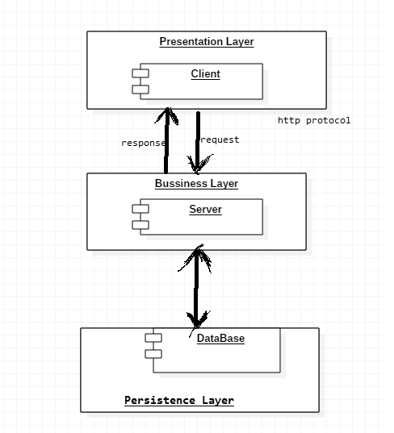

# DB design

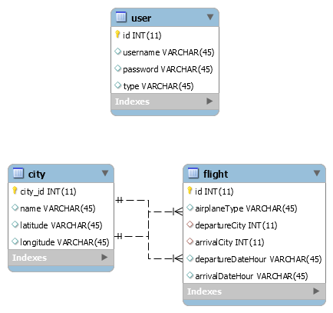

# UML Deployment diagram

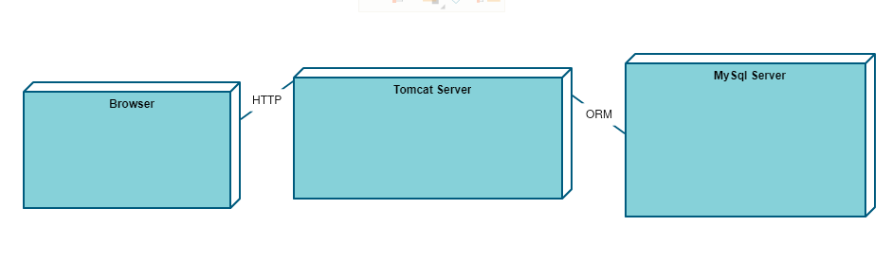

# Read me

Pentru a rula aplicatia trebuie sa urmati urmatorii pasi:

1. instalati serverul tomcat versiunea 7.0.91
2. asigurati-va ca serverul tomcat ruleaza pe portul 8080
3. adaugati in directorul de la adresa <director-instalare-tomcat>/lib fisierul jar care contine un driver mySql
4. instalati un server MySql
5. asigurati-va ca user-ul serverului este root si are parola root
6. asigurati-va ca serverul MySql ruleaza pe portul 3306
7. importati in server schema bazei de date
8. instalati maven versiunea 3.0.9 si adaugati calea la PATH
9. descarcati proiectul
10. in terminal, navigati in folderul radacina al proiectului
11. executati comanda mvn clean install
12. in terminal, navigati la <director-instalare-tomcat>/bin/startup.bat
13. intrati in browser la adresa <http://localhost:8080/login.html>